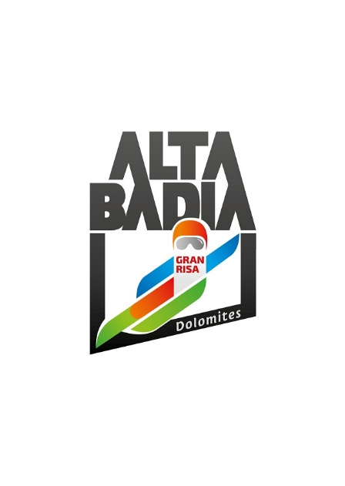PRESS RELEASE

**ALTA BADIA**

**39TH ALPINE SKI WORLD CUP:**

**THE GRAN RISA SLOPE IS READY FOR THE SHOW**

**Preparations are in full swing in Alta Badia for the two Alpine Skiing World Cup races, which will take place on Sunday 22 and Monday 23 December on the Gran Risa slope, one of the most technical and spectacular tracks of the entire Ski World Cup. On the programme this year are a men's giant slalom and a men's special slalom. The public will again be able to choose between the grandstands and the hospitality areas - LEITNER VIP Lounge, Red Bull Energy Lounge and Gran Risa Chalet. Ticketing is scheduled to open on Tuesday, 15 October at** [**www.skiworldcup.it**](http://www.skiworldcup.it)**.**

**Alta Badia (South Tyrolean Dolomites/Italy)** – The world's best men's alpine skiing athletes will compete in Alta Badia, in a giant slalom and a special slalom, scheduled for Sunday 22 and Monday 23 December. The renowned tourist resort, located in the heart of the Dolomites, a UNESCO World Heritage site, has a long tradition in organising Alpine Ski World Cup races. For no less than 39 years, in fact, Alta Badia has been one of the most eagerly awaited stages of the Ski World Cup. Under the leadership of Andy Varallo, the Organising Committee strives every year to guarantee flawless events, while making continuous improvements.

Thanks to the hospitality areas, this edition will also be dedicated to sport and lifestyle. Fans of this sporting discipline will be able to support their favourites live, on the grandstands at the parterre, or from the three hospitality areas, ready to welcome the numerous fans.

**HOSPITALITY AREAS: THE WINNING COMBINATION OF SPORT, MUSIC, LIFESTYLE AND CULINARY EXCELLENCE**

Alta Badia is increasingly emerging as a location that offers the highest intensity of finest indulgent moments in the mountains. In this vein, the Alpine Ski World Cup races are a unique opportunity to discover the excellence of the area. The races represent, in fact, the highlight of skiing-related moments in Alta Badia. The three hospitality areas of the event offer authentic moments of pleasure, each based on the main values of the area, namely high-level cuisine, the majesty of the Dolomites and Ladin culture.

The excellence of gourmet cuisine is once again at home in the LEITNER VIP Lounge, located on the rooftop of the building, overlooking the Gran Risa slope. Leitner, one of the world's leading ropeway manufacturers, and Alta Badia are united by the same innovative force. ‘Our company history is strongly linked to Alta Badia. A relationship that took its first steps back in 1947 with the first chairlift built in Italy, the Col Alt chairlift in Corvara. Over the decades, the collaboration has been further strengthened and developed into a friendship. Together we were able to face and overcome many challenges, which strengthened our bond, characterised by mutual help and the ability to learn from each other'. With these words Anton Seeber, president of LEITNER, describes the relationship of esteem and friendship that has been renewed time and again for more than 75 years. From the LEITNER VIP Lounge there is the possibility to follow the races from a privileged position and to spend a few hours in complete tranquillity, tasting a good glass of wine, paired with the dishes, created on Sundays by the star chef, Peter Brunel of the Peter Brunel Ristorante Gourmet in Arco. Brunel has made a green philosophy a vocation, inspired by the cuisines of the world, but always returning to the Alps at home. The gastronomic proposal of Monday 23 December at the LEITNER VIP Lounge will instead be entrusted to Tina Marcelli of the Artifex restaurant in Val di Fleres and chef Johann Lerchner of the restaurant Lerchner's in San Lorenzo di Sebato. Together, the two chefs will present a four-handed menu, which combines a passion for the culinary tradition of the region and a focus on the sustainable sourcing of ingredients, which are strictly seasonal. The interior of the LEITNER VIP Lounge is furnished in a modern and refined style, with areas dedicated to sharing such as the cosy wine bar and more intimate and secluded corners, ideal for a business meeting. The service for guests is continuous; some of the best South Tyrolean products, such as speck and cheese, will be served throughout the day, paired with excellent South Tyrolean wines and sparkling wines, in cooperation with the Wine Consortium Alto Adige, the Association of Alto Adige sparkling wine producers and IDM Alto Adige. Tickets are on sale at a price of 310€ for Sunday and 225€ for Monday.

In the Red Bull Energy Lounge, the pioneering mood of Alta Badia meets the high ambitions of Red Bull and together they once again create a lounge, unique in the entire World Cup circuit. It is a building with a large terrace, positioned directly in the finish area, where fans can watch the races from the front row and from a privileged position, just like in the starting pits of a Formula 1 or MotoGP race. In this lounge you can toast with Drusian's bubbles, which will also be the bubbles for the awards ceremonies of the two races. “*We are very proud to be the official sponsor of the World Cup races in Alta Badia for the third year in a row.* - says Francesco Drusian, owner of the eponymous winery in the heart of the Valdobbiadene hills - *Our company shares with this prestigious event the values of determination and passion that characterise the athletes and that we promote in our work. For us, supporting the Ski World Cup is not only an opportunity to be present at an event of international importance,*" continues Francesco, "*but also a way to support and promote two areas that are very dear to us: the Dolomites and the hills of Conegliano and Valdobbiadene, both World Heritage Sites. We would like to thank the organisation for this collaboration and we are delighted to be able to raise our glasses once again with the many fans of this sport”.*

Tickets are on sale at the price of 245€ for Sunday and 215€ for Monday.

The more traditional, all wood-panelled lounge is instead called Gran Risa Chalet. This hospitality area is dedicated to Ladin traditions and culture and will host the partners Forst, Oakley and Movimënt for the occasion. In addition to being set up in mountain style, it will provide the opportunity to taste some of the best dishes of the local, simple but genuine cuisine. The Gran Risa Chalet will make it possible to be in close contact with personalities from the world of sport, as the hospitality area will also be used as a stage, where talks and meetings with athletes will be organised.

Tickets for a grandstand seat are priced from € 30.00 for both Sunday and Monday.

The Ski World Cup weekend starts already on the evening of Saturday 21 December at 19.00 with the bib draw in the centre of La Villa, followed by the party organised by the fire brigade in the marquee set up directly on the Gran Risa parterre.

**OPENING OF TICKETING AND RELAUNCH OF THE MGZN+**

All ticket types can be purchased online at [www.skiworldcup.it](http://www.skiworldcup.it) from Tuesday 15 October. On November 12, the online magazine, called MGZN+ (Magazine Plus), will be relaunched with new content. It is a dynamic magazine, dedicated entirely to the Ski World Cup in Alta Badia, capable of capturing the attention of the reader, who in addition to reading the articles, has the possibility of delving deeper into the contents read, through videos, slide-shows of images, or by making purchases online, thanks to the e-shop button.

**PARTNERS AND SPONSORS: UNITY IS STRENGTH**

The OC Alpine Ski World Cup Alta Badia would like to thank all partners for their support. The partners and sponsors of the World Cup races in Alta Badia are an integral part of the event and contribute to making also this edition unique and special. This confirms the solid relationship that has been established over the years between partners and the OC Alpine Ski World Cup Alta Badia.

**For further information:**

Alpine Ski World Cup Alta Badia – [www.skiworldcup.it](http://www.skiworldcup.it) – Phone +39 0471/830161 – Email: [info@skiworldcup.it](mailto:info@skiworldcup.it)

Tourist Offices Alta Badia – [www.altabadia.org](http://www.altabadia.org) – Phone +39 0471/836176-847037 – Email: [info@altabadia.org](mailto:info@altabadia.org)

**Alta Badia Press Office:**

Nicole Dorigo: Mob. +39 338/9506830 – Email: [press@altabadia.org](mailto:press@altabadia.org)

Stefanie Irsara: Mob. +39 340/8738833 – Email: [stefanie.irsara@altabadia.org](mailto:stefanie.irsara@altabadia.org)