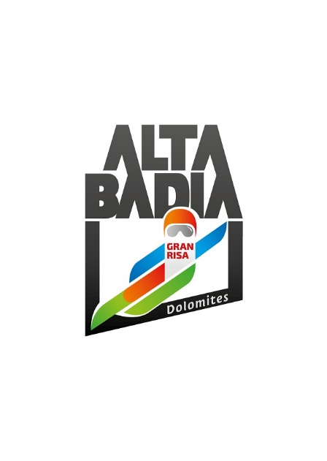PRESS RELEASE

**ALTA BADIA**

**COUNTDOWN TO THE SKI WORLD CUP RACES ON THE GRAN RISA STARTED**

**Sunday 22 and Monday 23 December is the date for the men's races on the Gran Risa slope, valid for the Alpine Ski World Cup. The world's best athletes will be at the starting gate, including the eagerly awaited Lucas Pinheiro Braathen, who is racing for Brazil this year.**

**Alta Badia (South Tyrolean Dolomites/Italy)** - The countdown has started. The Gran Risa is completely covered in snow and the whole valley is surrounded by an air of celebration. A Giant Slalom and a Special Slalom will take place on Sunday 22 and Monday 23, on one of the most spectacular and challenging slopes of the entire Skiworldcup.

The Organising Committee, headed by Andy Varallo, is constantly working to ensure flawless races and continuous improvements. The starting gate is already assembled and the anticipation is growing for 10 a.m. on Sunday 22 December, when the best athletes in the world will compete on the legendary Gran Risa slope in a giant slalom. The second run is scheduled for 1.30 p.m. The special slalom will take place on Monday, 23 December, at the same time.

Thanks to the hospitality areas, this edition will also be dedicated to sport and lifestyle. Fans of this sporting discipline will be able to support their favourites live, on the grandstands at the parterre, or from the three hospitality areas (the Leitner VIP Lounge, the Red Bull Energy Station and the Gran Risa Chalet), ready to welcome the numerous fans. Tickets for the races are on sale, subject to availability, online at www.skiworldcup.it, or directly at the finish area on race days. Those who are unable to follow the athletes directly from the finish area can cheer them on from home, thanks to the worldwide broadcast of the races.

The public present at the Giant Slalom on Sunday 22 December will have the opportunity to watch the flight of the PAN Frecce Tricolori between the two runs.

Once again this year, the top three will receive trophies made by artist Daniele Basso, author of the GIGANT sculpture, installed at the start of the Gran Risa slope for the 30th anniversary of the event. This year's trophy is intended as a hymn to sport as a pillar in modern society. During the award ceremony, the winners will be presented with bubbles from the Drusian Winery, a great way to celebrate the podium.

On Monday, 23 December, the ski lifts on the Alta Badia plateau open their doors at dawn to give life to SunRisa, with the chance for skiers to see the sun rise at 2000m and ski down virgin slopes. In combination with this, a hearty breakfast, based on wholesome and healthy products, can be enjoyed at the Club Moritzino, Ütia I Tablá, Ütia Bioch, Ütia Piz Arlara and Ütia Las Vegas refuges. The various dishes on offer have been created with the support of nutritionist Elena Casiraghi and contain the basic ingredients for a healthy breakfast.

Curiosities and in-depth information on the Alta Badia World Cup races can be found in the MGZN+ (Magazine Plus). The online magazine, dedicated entirely to the races on the Gran Risa slope, is able to capture the attention of the reader, who in addition to reading the articles, has the possibility of delving deeper into the content read, through videos, slide-shows of images, or by shopping online, thanks to the e-shop button. mgzn.skiworldcup.it

**COLLABORATION WITH ILMETEO.IT**

Also this year, thanks to the renewed partnership with iLMeteo.it, it will be possible to take advantage of ‘real time’ monitoring of weather forecasts, before and during the races. This is an important service to fully enjoy the sporting experience, both for those working in the field and for the numerous spectators who will follow the races from the finish area. Lorenzo Tedici, meteorologist of iLMeteo.it, will be in Alta Badia to provide updates on temperature, wind and possible precipitation. More information on ilmeteo.it.

**TEST THE BEST TO CHOOSE THE BEST WINTER PRODUCTS**

On 22 and 23 December, on the occasion of the Ski World Cup races in Alta Badia, the best ski and sportswear brands meet for ‘Test the Best’. The test village allows you to discover and try out all the novelties for winter 2024/2025 directly on the slopes. The expert ski instructors of Alta Badia will provide valuable advice on the new equipment and guide the participants along the slopes. The appointment is Sunday 22 from 9:30 a.m. to 3 p.m. and Monday 23 December from 8:30 a.m. to 3 p.m. at the Piz La Ila cable car in La Villa.

**HAPPY BIRTHDAY DOLOMITI SUPERSKI**

Dolomiti Superski celebrates 50 years as one of the leading Alpine tourist destinations worldwide. Founded in 1973 and operational since 1974, initially as Superski Dolomiti and then, since 1984, as Federconsorzi Dolomiti Superski, it has united 12 Dolomite valleys into a single system. This consortium offers access to 1,200 km of slopes and 450 lift facilities with a single ski pass. The Federconsorzi manages ski pass sales, marketing and relations with local authorities, without directly owning the infrastructure, which is instead managed by the individual local companies.

**AUDI DRIVING EXPERIENCE IN CORVARA**

A paradise for nature lovers, the Dolomites are also the ideal place for exciting performances. For this reason, Audi is offering the chance to experience quattro all-wheel drive at first hand amidst the evocative landscapes of Alta Badia, for an intense and exclusive experience on board the e-tron range.

The high-tech models of Audi's 100% electric range allow you to discover a new vision of cutting-edge technology through the unique routes of the Dolomites.

The experience includes a road test drive to put the RS or e-tron models to the test and all the excitement of parkour on board the Q range.

**PARTNERS AND SPONSORS: UNITY IS STRENGTH**

The OC Alpine Ski World Cup Alta Badia would like to thank all partners for their support. The partners and sponsors of the World Cup races in Alta Badia are an integral part of the event and contribute to making also this edition unique and special. This confirms the solid relationship that has been established over the years between partners and the OC Alpine Ski World Cup Alta Badia.

**For further information:**

Alpine Ski World Cup Alta Badia – [www.skiworldcup.it](http://www.skiworldcup.it) – Phone +39 0471/830161 – Email: [info@skiworldcup.it](mailto:info@skiworldcup.it)

Tourist Offices Alta Badia – [www.altabadia.org](http://www.altabadia.org) – Phone +39 0471/836176-847037 – Email: [info@altabadia.org](mailto:info@altabadia.org)

**Alta Badia Press Office:**

Nicole Dorigo: Mob. +39 338/9506830 – Email: [press@altabadia.org](mailto:press@altabadia.org)

Stefanie Irsara: Mob. +39 340/8738833 – Email: [stefanie.irsara@altabadia.org](mailto:stefanie.irsara@altabadia.org)