PRESS RELEASE

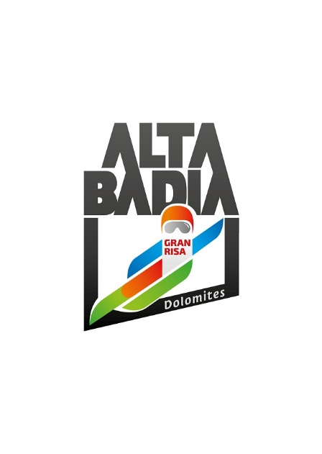

**ALTA BADIA – SKIWORLDCUP**

**GRAN RISA SLOPE: WHERE CHALLENGE MEETS SPECTACLE**

**In Alta Badia, people are working non-stop to ensure an excellent organisation of the Alpine Ski World Cup races, scheduled for 22 and 23 December 2024.**

**Alta Badia (South Tyrolean Dolomites/Italy) –** The men's Alpine Ski World Cup will return to Alta Badia on the last weekend before Christmas, as is tradition. On Sunday 22 and Monday 23 December, a giant slalom and a special slalom are scheduled on one of the most technical and challenging slopes of the entire Ski World Cup, where the best athletes on the international scene will compete. A festive atmosphere will await the numerous fans in the hospitality areas - Leitner VIP Lounge, Red Bull Energy Lounge and Gran Risa Chalet - located at the foot of the Gran Risa. Tickets for the hospitality areas, grandstands and trackside are available online at [www.skiworldcup.it](http://www.skiworldcup.it).

For those who cannot be present on site, the races will be broadcast worldwide: the first heat at 10 a.m. and the second at 1.30 p.m., to allow everyone to cheer on their favourites.

**TROPHIES 2024: SPORT AS A PILLAR IN MODERN SOCIETY**

The trophies, which will be awarded to the top three finishers, will again this year be the work of artist Daniele Basso, author of the GIGANT sculpture, installed at the start of the Gran Risa slope for the 30th anniversary of the event.

The artist himself describes the trophies created for this edition as follows: ‘In the “gaseous” modernity theorised by Francesco Morace as an updated sociological profile of contemporaneity, sport and the universal values it represents assert themselves as a solid foothold to be relied upon to face life with confidence. The circle, also in honour of the forthcoming Winter Olympics, becomes a symbol of the fullness of the sporting discipline that unites body and mind aimed at achieving a goal, the new record, beyond which the entire human race evolves towards new boundaries. Skiing in the dimension of challenging oneself against time, without apology, becomes a measure of our determination to grow, learn, evolve and strive for the future we desire.’

**MUSIC AS THE PROTAGONIST OF THIS EDITION**

This year, the Ski World Cup in Alta Badia celebrates the fusion of sport and music, making the latter the true protagonist of the event. An enthralling experience that will accompany spectators at every stage of the races: from moments of anticipation to moments of elation for the athletes' performances. Energetic rhythms and exciting melodies will spread from the grandstands to the hospitality areas, giving the audience a vibrant and unforgettable atmosphere. Among the groups that can be admired, an all-female quartet stands out: the Alter Echo String Quartet. This is a crossover group, founded in 2011, that combines classical and pop music, collaborating with internationally renowned artists such as Andrea Bocelli, Elodie, Mario Biondi, Il Volo and many others. They have participated in prestigious events, such as Google Camp, and performed at exclusive occasions such as the MSC Grandiosa cruise and Andrea Bocelli's concert in Saudi Arabia. In 2023, they accompanied Pooh on their tour and collaborated with Netflix and F. Baccini. Their repertoire ranges from baroque to rock, offering a musical journey that embraces different styles and eras. At the Ski World Cup in Alta Badia, they will make their debut in the VIP Leitner Lounge, a hospitality area that this year for the first time also sees Numia, a wholly Italian company that is established on the market as ‘the second pole of monetics’, as co-partner. They will also perform in the finish area on Sunday 22 December during the interval between one run and the next.

**SUNRISA: SKIING AT DAWN ON FRESH SNOW, BEFORE ENJOYING A HEARTY BREAKFAST AT 2,000M**

Skiing on fresh snow, before anyone else, is a truly unique experience. The experience becomes even more magical if you do it in the heart of the Dolomites, a UNESCO World Heritage Site, on Alta Badia's slopes, where the best athletes will be going head-to-head at the Alpine Ski World Cup during the same period, all topped off with an excellent breakfast at 2,000 m a.s.l.

On Monday 23rd December, the ski slopes on the plateau of Alta Badia will be opening at dawn, giving ski enthusiasts the chance to see the sun rise at 2,000 m a.s.l. and ski down the slopes that have been perfectly prepared the night before by the many snowcats that work in the area. What’s more, there is the chance to enjoy a hearty breakfast, based on genuine and healthy products, at the Club Moritzino, Ütia I Tablá, Ütia Bioch, Ütia Piz Arlara and Ütia Las Vegas mountain huts. Each hut will be paired with a specific breakfast item, such as milk, cereal, eggs or fruits. The various dishes on offer have been created with the support of the nutritionist Elena Casiraghi and they contain the essential ingredients for a perfect breakfast, guaranteeing the right number of calories and nutrition for each leg of the breakfast route from one mountain hut to another.

**PARTNERS AND SPONSORS: UNITY IS STRENGTH**

The OC Alpine Ski World Cup Alta Badia would like to thank all partners for their support. The partners and sponsors of the World Cup races in Alta Badia are an integral part of the event and contribute to making also this edition unique and special. This confirms the solid relationship that has been established over the years between partners and the OC Alpine Ski World Cup Alta Badia.

**For further information:**

Alpine Ski World Cup Alta Badia – [www.skiworldcup.it](http://www.skiworldcup.it) – Phone +39 0471/830161 – Email: [info@skiworldcup.it](mailto:info@skiworldcup.it)

Tourist Offices Alta Badia – [www.altabadia.org](http://www.altabadia.org) – Phone +39 0471/836176-847037 – Email: [info@altabadia.org](mailto:info@altabadia.org)

**Alta Badia Press Office:**

Nicole Dorigo: Mob. +39 338/9506830 – Email: [press@altabadia.org](mailto:press@altabadia.org)

Stefanie Irsara: Mob. +39 340/8738833 – Email: [stefanie.irsara@altabadia.org](mailto:stefanie.irsara@altabadia.org)